Test Plan
Test Plan Project: Student Grade & GPA Calculator
SDLC Model: Waterfall
1. Introduction
This document describes the testing activities for the Student Grade & GPA Calculator system. The goal is to make sure all functional requirements work correctly.
2. Test Scope
- In Scope: All 11 functional requirements (FR-01 to FR-11) and all 11 use cases.
- Out of Scope: Performance testing, security testing, and mobile responsiveness.
3. Test Strategy
- Testing includes Unit, Integration, and System testing.
- Both positive and negative test cases are included.
- All testing is done manually.
4. Test Environment
- Language: JavaScript (HTML + CSS + JS)
- Browser: Google Chrome
- Operating System: Windows 11
- Tools: VS Code, GitHub, Live Server
5. Test Deliverables
- This Test Plan
- Executed Test Cases (shown below)
- Sample User Manual

Test Cases
Positive Test Cases:
Test Case ID | Use Case FR | Test Description | Test Steps | Expected Result | Actual Result | Status
TC-1 | UC-1  FR-1 | Check main menu options | Open the application in browser | Menu shows 3 options (Grade from Mark, GPA Marks, GPA Letter) | Menu displayed correctly | Pass
TC-2 | UC-2  FR-2 | Enter number of courses | 1. Choose GPA using marks 2. Enter 4 courses | System accepts number and moves to input fields | Accepted 4 and generated fields | Pass
TC-3 | UC-5  FR-5 | Delete a course | 1. Add 3 courses  2. Delete the second course | Course is removed and list updates | Course deleted successfully | Pass
TC-4 | UC-6  FR-6 | Convert mark to letter grade | 1. Enter mark = 87 | System shows letter grade “B+” | Displayed “B+” | Pass
TC-5 | UC-7  FR-7 | Convert letter grade to points | Enter grade = A- | System converts to 3.4 points | Converted to 3.4 | Pass
TC-6 | UC-8  FR-8 | Calculate GPA  (4 courses) | 1. Enter 4 courses with valid data  2. Click Calculate | GPA calculated correctly | GPA = 3.45 | Pass
TC-7 | UC-10  FR-10 | GPA rounded to 2 decimal places | 1. Calculate GPA that gives 3.666… | System shows 3.67 | Displayed 3.67 | Pass
TC-8 | UC-11  FR-11 | Perform new calculation without restarting | 1. Finish one calculation  2. Choose “Calculate Again” | Returns to main menu | Returned to menu successfully | Pass

Negative Test Cases:
Test Case ID | Description | Steps | Expected Result | Actual Result | Status
NTC-1 | Enter 0 courses | Enter number of courses = 0 | Error message “Minimum 1 course” | Error shown | Pass
NTC-2 | Enter mark out of range (105) | Enter mark = 105 | Error “Mark must be 0-100” | Error shown | Pass

Sample User Manual
How to use the system:
- Open the application in your browser. | https://precious-bonbon-e4dec0.netlify.app/
- You will see the main menu with 3 options:  - Calculate Grade from Mark  - Calculate GPA using Marks  - Calculate GPA using Letter Grades  3. Choose the option you want. | 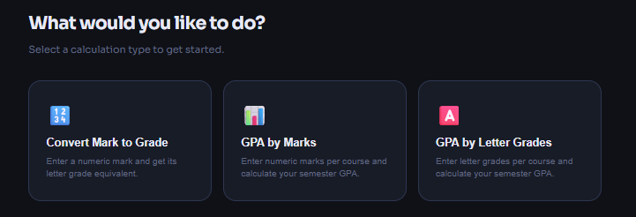
If you choose GPA calculation: | 
4. Enter the number of courses (example: 6). | 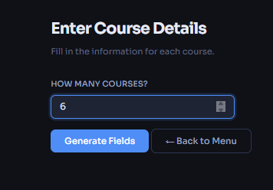
5. The system will create input fields automatically for each course.  6. For every course fill in:  - Course name  - Credit hours  - Mark or Letter grade (according to the method you chose) | 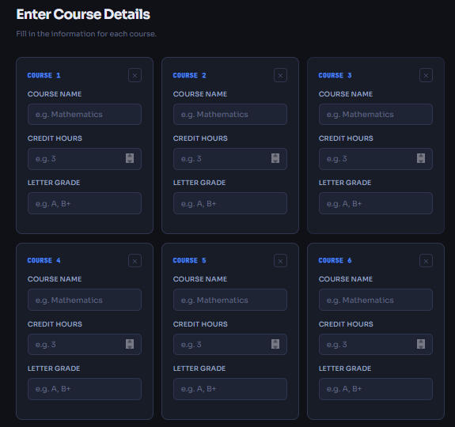
- If you want to remove a course → click the delete button next to it. | 
- After finishing all courses, click Calculate. | 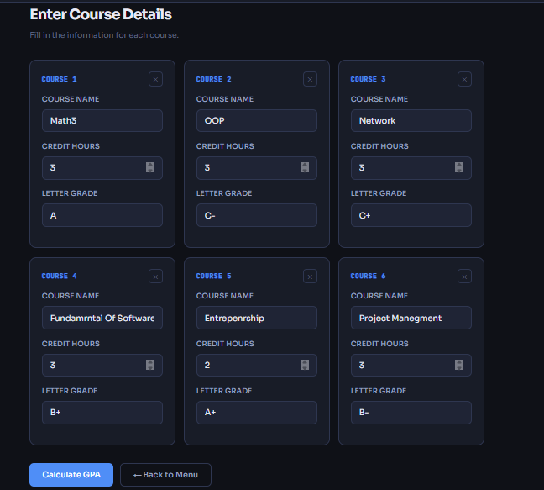
- The result will appear (letter grade or GPA rounded to 2 decimal places). | 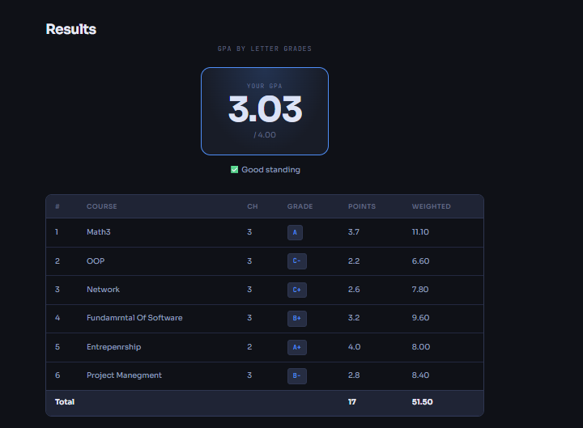
- You can click Calculate Again to do a new calculation without closing the program. | 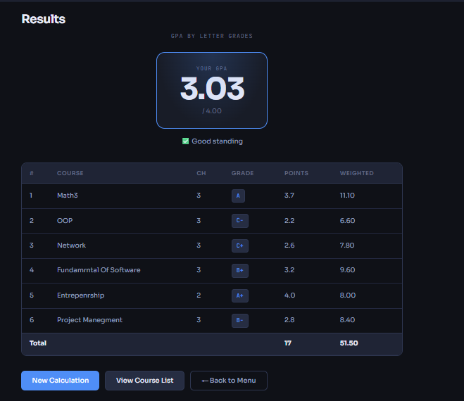
Notes:  The system will show error messages if you enter wrong data (like negative credit hours or mark above 100). | 